Typical Channel prior to scan

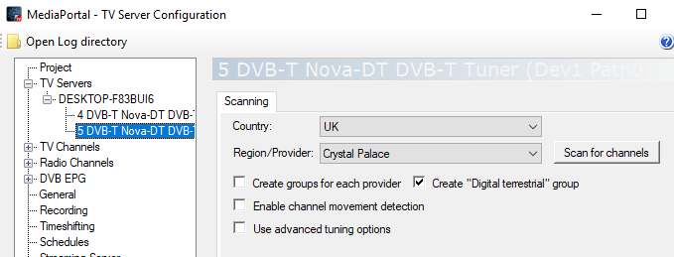
TV channel mapping – single station on each port – NO EPG
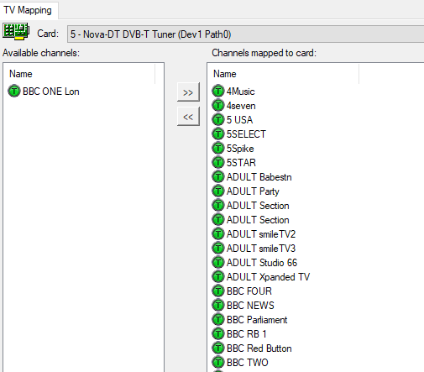
No Radio stations selected
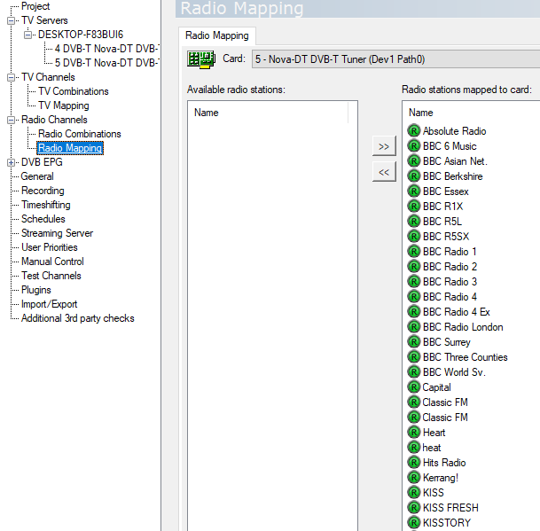

DVB- EPG hopefully not available
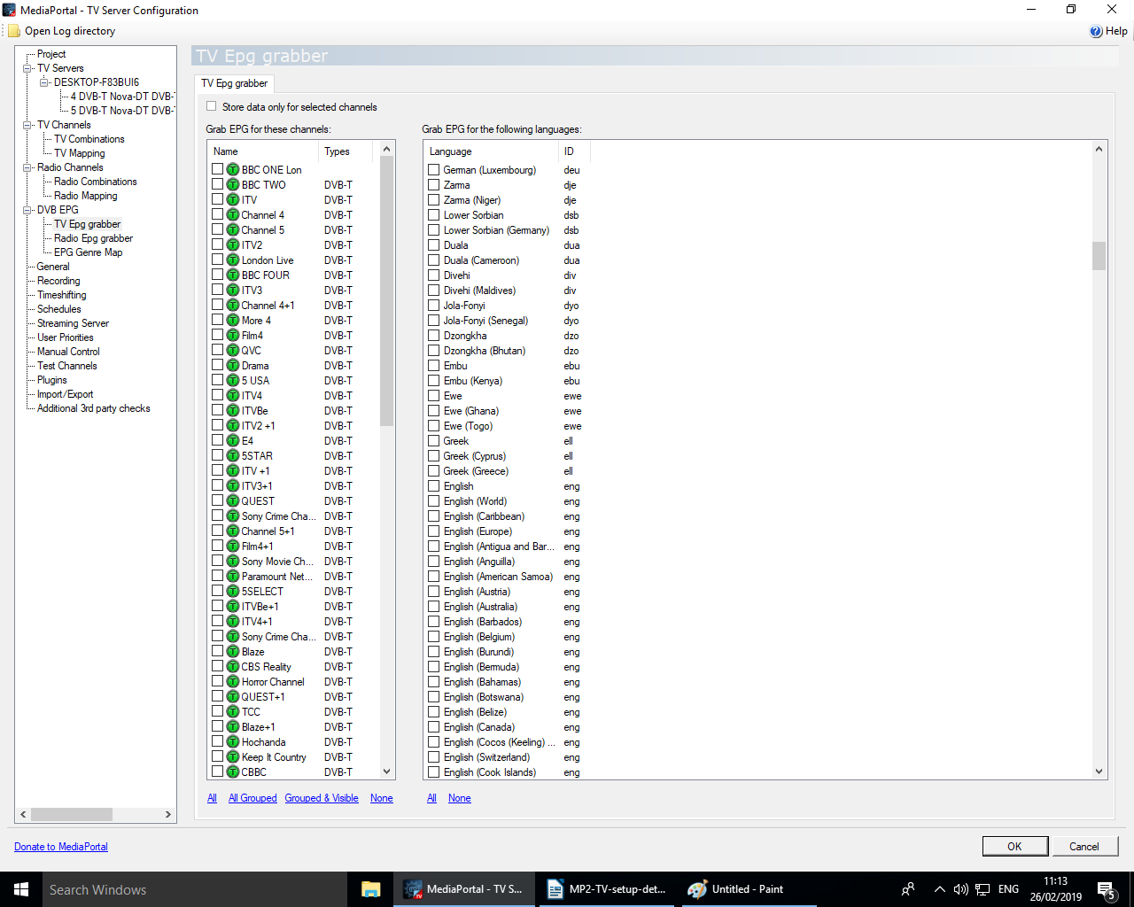

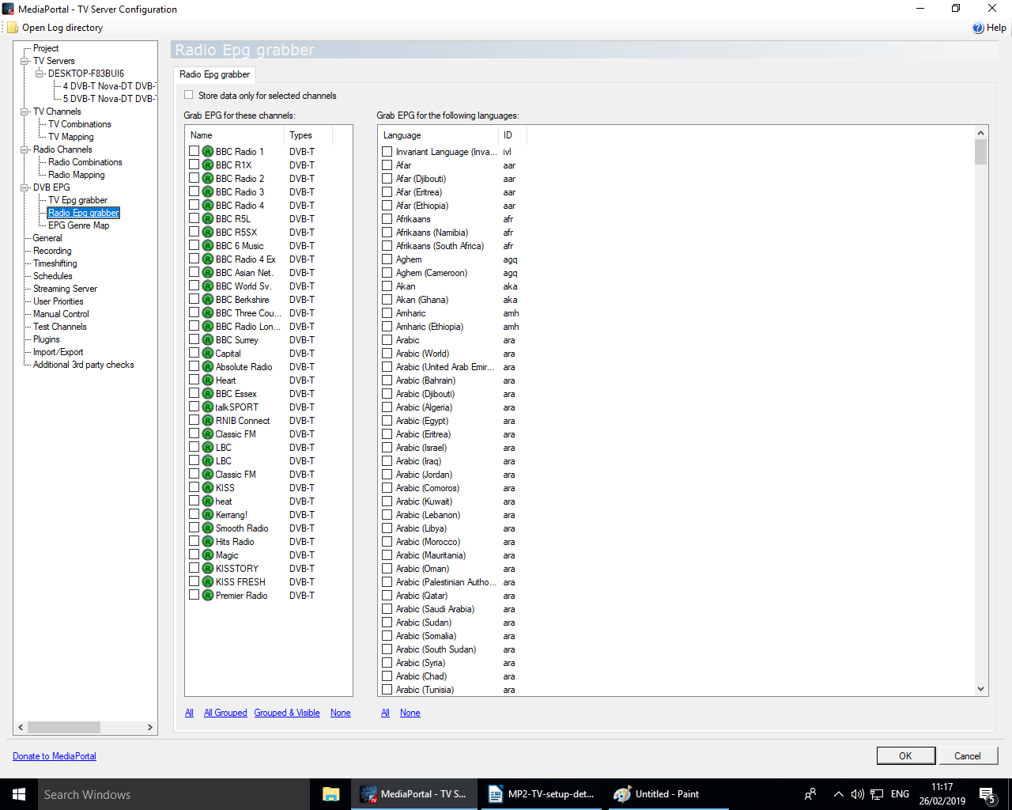

Testing all stations – although really interested in getting one to work
I changed some timing parameters, requested 1 channel to be used although there are 2 idle.

There are 90 stations detected .

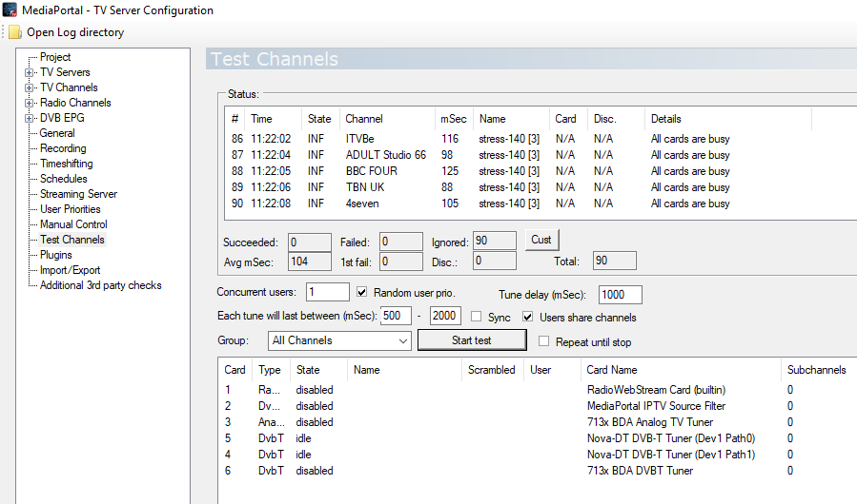

Question – why are all cards busy ?
Question – how do I rectify problem
Question – why 90 stations tested rather than 1 selected in TV mapping

