MediaPortal Won’t Start:
Symptoms:
- MediaPortal won’t start. No splash screen. The Taskbar doesn’t hide. NOTHING! The Windows is busy spinning circle appears for a few seconds, then nothing.
- Most likely neither MediaPortal, nor MediaPortal Configuration will start, but TV Server Configuration WILL likely start.
- If you clear the logs folder and try and start MediaPortal or MP Configuration, there will either be no log files created at all, or if they are created, they will be empty.
- If you check the Windows Application Event Log, you will likely get these two Error entries, one after the other, every time you try and start MediaPortal:

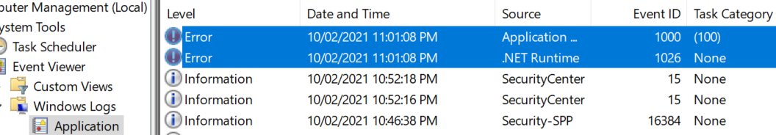

- With the following details:
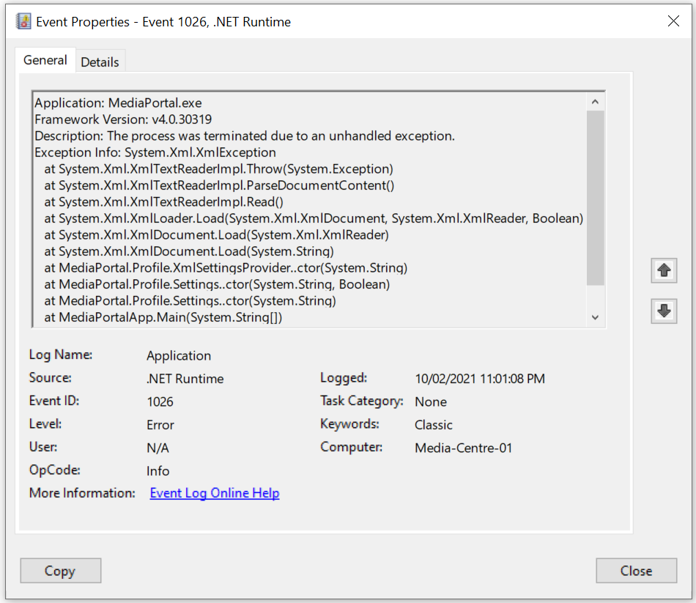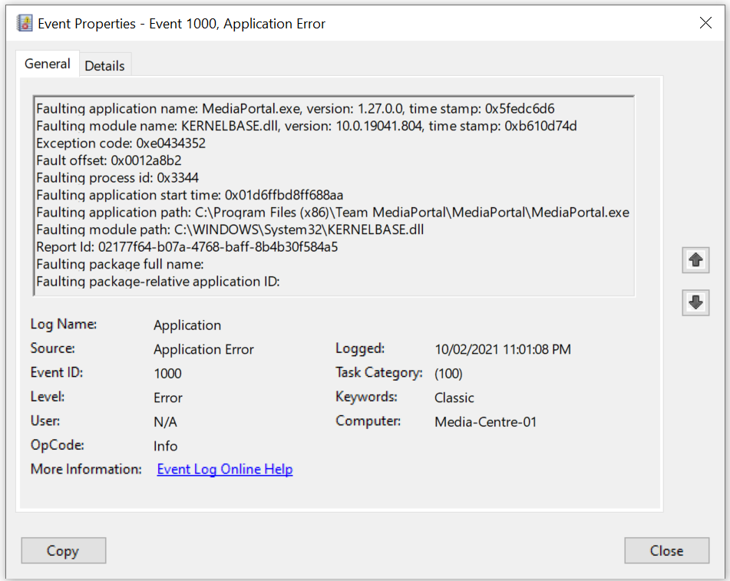

What is Stopping MediaPortal from Starting?: One or more *.xml files located in C:\ProgramData\Team MediaPortal\MediaPortal have been corrupted or the contents have been erased. Typically, it is only the MediaPortal.xml file that is damaged, but there may be others.

What Caused this Problem?: These *.xml files can become corrupted or their contents erased when either the computer or MediaPortal software is not properly shutdown. Typically caused by a mains power failure, forcing a shutdown of your computer, or forcefully shutting down MediaPortal or MediaPortal Configuration via Task Manager.

How to Check if these *.xml files are Corrupted?: Just double-click on one of the *.xml files and they will typically open in Internet Explorer. If not, use Open With to select Internet Explorer and open the file. I suggest checking MediaPortal.xml. You will likely find that the file is empty, which is proof of corruption. For reference, it should look something like this:
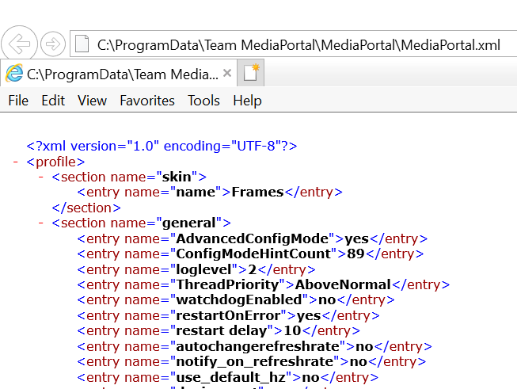

How to Resolve the Problem: Backups of the C:\ProgramData\Team MediaPortal\MediaPortal folder are created in C:\ProgramData\Team MediaPortal. Look for folders with “_BACKUP” in the name. I presume a backup is created every time MediaPortal is updated?? Find the latest backup, that still contains an un-corrupted copy of the MediaPortal.xml file and copy this file (And any other *.xml files that need to be replaced) to the C:\ProgramData\Team MediaPortal\MediaPortal folder.

