MediaPortal Refactor – How to use it

MediaPortal Refactor – How to use it

Introduction
This document describes how to use the refactored MediaPortal application. This version is not certified for the bulk of the extensions – some might work, but they have not been tested. The following features have been tested:
- LAV filters;
- Fanart;
- Video;
- Music;
- Pictures.
This version was specifically designed to make full use of centralized configuration; i.e. placing MediaPortalDirs.xml in the Team Mediaportal folder of your Users section.

Background
MediaPortal (MP), MP1 in particular, worked with isolated clients, each having its own set of client databases. The refactored version allows you to place all of your client databases in one location and for all of your MP1 clients to access those databases directly.
This version will allow you to perform tasks while you are using the system that would have been unreliable previously. Users should be aware that the system may run slower when running large background tasks like rebuilding the client databases.
This document will explain how to make best use of the multi-user environment and how to configure your system with least user input.
The developer has attempted to make the database design as future-proof as possible and it is intended that no further databases design changes be necessary or that, at least, any design changes will be trivial (making upgrades simpler to implement).
NOTE: the refactored system only affects the client side of the system. The tuner and program database side of the system remains unchanged.

Document Content
This document will cover the following topics:
- Getting Started;
- Subsequent Installations.

Who should read this document
This document is intended for any MP users that wish to make use of a multi-user environment for MediaPortal. This document will not be technical in nature; it will explain how to use new features and how to make best use of the multi-user facilities.

Getting Started
Previous versions of MP1 upgraded the new version based on the contents of the old versions’ databases. This version is so fundamentally different at the database end, that it was felt better that users should become familiar with how to rebuild their system from scratch. In essence, MP1 is a closed system. No damage will be done if something goes wrong. You will always be able to rebuild your system and use it at the same time; due to the now available multi-user set-up.
It is believed that you will gain greater understanding of your system when you set it up fully yourself from scratch. This process will allow you to spot issues later on and be better able to fix them.

The First Step
It is assumed that MP1, 1.29, is already installed and working. The refactored version over-writes certain files of an existing installation. Once the refactored version has been installed you should not use the system until you have set-up the client databases.
NOTE: There will always be a new version of the refactored version whenever MP1 is upgraded. The main difference between the first installation and future upgrades is that you do not need to delete your client databases when upgrading in future.
You must perform the following tasks in the same order:
- Set-up your client database;
- Configure your system for centralized client databases;
- Delete all of your client databases;
- Run the configuration application.

Setting-up your client databases
The databases for the refactored version are different from those of previous versions. Therefore, your first step will be to delete your current client databases. MP1 will create your new databases automatically. You should then take steps to populate your databases with information about any existing media you intend to use with MP1.

Configuring your system for centralized client databases
Do not run MP1 until you have performed the following task; ensure that you have configured your system so that all of your client systems are accessing the same database location. At the same time you can set-up common locations for your configuration, thumbs, logs, skins, cache and plugins. This has been a long-standing feature of MP1 and you can read how to set this up in the MP1 documentation.

Delete all of your client database
Now you have set-up where your databases will be located, ensure that the database folder is empty.

Run the Configuration application
It is recommended that you use the configuration application to populate your client databases with information about your media at the set-up stage. Of course, you may use the GUI to perform the same task; but the GUI only allows you to process one element of media at a time. The configuration application allows you to process all of your media for each element in one go:
- Video;
- Music;
- Pictures.
The configuration application will create default versions of each client database automatically. We will discuss Fanart processing later.

Video
It is assumed that you have already set-up your shared folders so the next step will be to put your films into your new database.
The author does not use the nfo scraper facility and has not knowingly changed any coding related to that feature. The changes to the system described below relate to standard film processing.
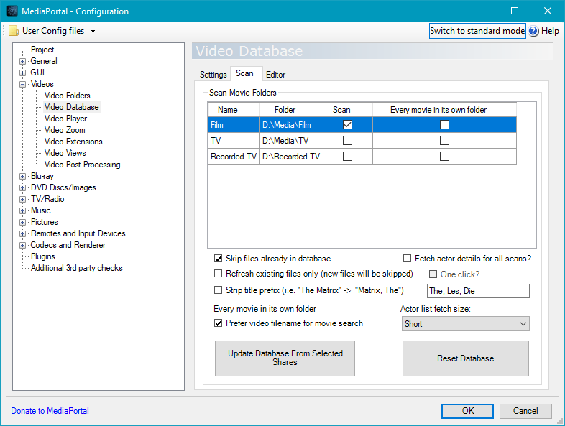

Users will be aware that scanning video information is quite rapid unless you decide to import actor details. The latter option will take several hours to import 100 films; with at least one click for each film. The refactored system provides a more practical way to import your films.
NOTE: this procedure only applies to non-nfo scans. Nfo scans ignore this procedure and work in the time- honoured way.
If you don’t need actor details, then you may simply leave the Fetch actor details for all scans? checkbox unchecked and press Update Database From Selected Shares. You will then have to press enter for each film you want to import, but each scan will be quite quick. Behind the scenes the system will store the information about which script you used to store each film.
If you do wish to get actor details you may now run a refresh – only this time check the One click? checkbox. By selecting this option you are telling the system you want to refresh your database using the same scripts you used last time. The configuration application will now get all of the actor details without any user intervention. This will probably take several hours. You will still be able to use MP1 because the system is now multi-user capable.
For those of you that are interested, movie records for your films are written when you perform the first scan irrespective of whether the scan is successful. The movieinfo records are written when each movie is successfully scanned in.
NOTE: the Fetch actor details for all scans checkbox is now synchronized with the GUI.

Music
The music database screen is unchanged. You should perform a scan now if you have any audio files you use in MP1.

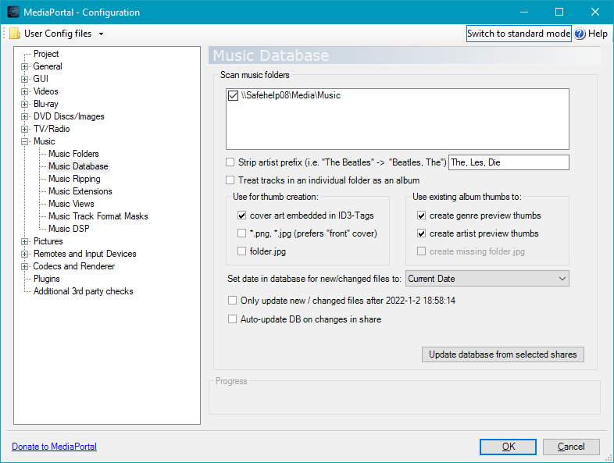

Pictures
Similarly, the Picture database should be populated now.

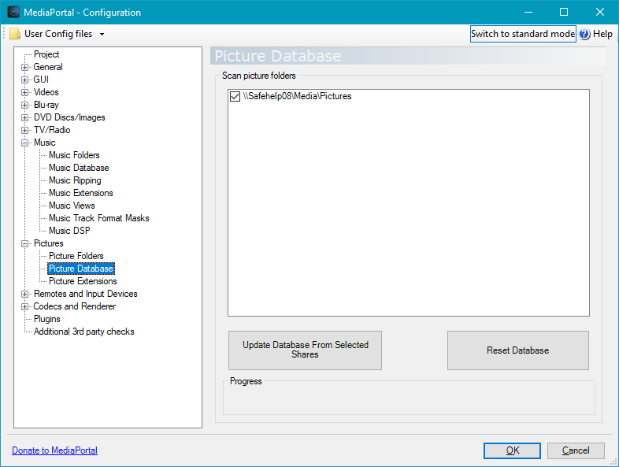

NOTE: Database updates are queued in the refactored MP1. Therefore, there will be times when database updates will still be occurring after the front-end processing has finished scanning. Please do not try to close the configuration application until after the background processing has finished - screen objects will be disabled until processing has finished. This is normal behaviour and you should not attempt to close the application by any other means (like using event manager to kill the application).

Main Configuration
There is a new setting in the Startup/Resume settings screen called Clear-down redundant data on start:

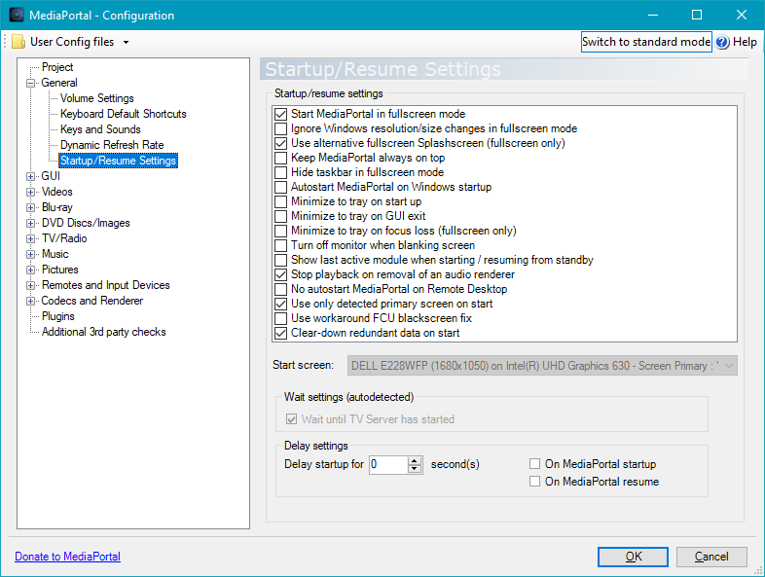

You are now able to decide whether you want MP1 to automatically clear down redundant data when MP1 starts up. Now that this option is available, I have been able to remove that processing from within the GUI. Is strongly recommended that this option be checked to ensure that your databases are optimal.
NOTE: stacked movies will not be removed until the all of the parts have been deleted (by users deleting the original video files).

Fanart
If you intend to use the Fanart facility, you should go into Plugins and select Fanart Handler:

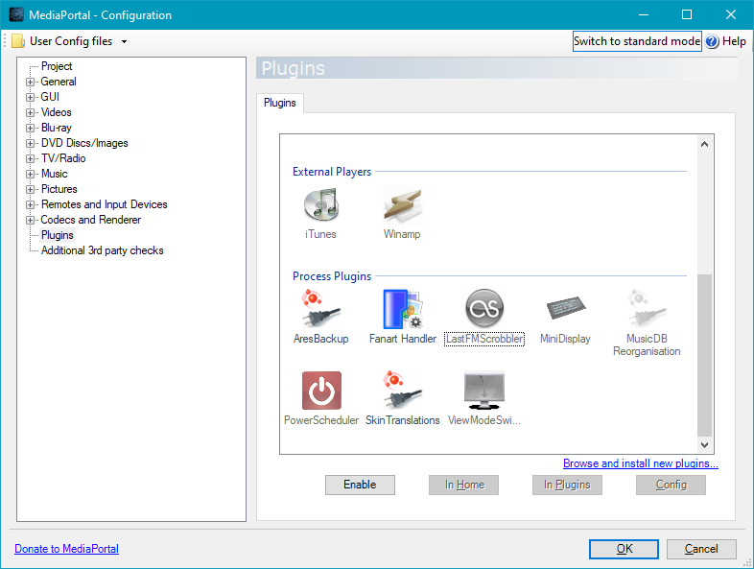

Now press Config:

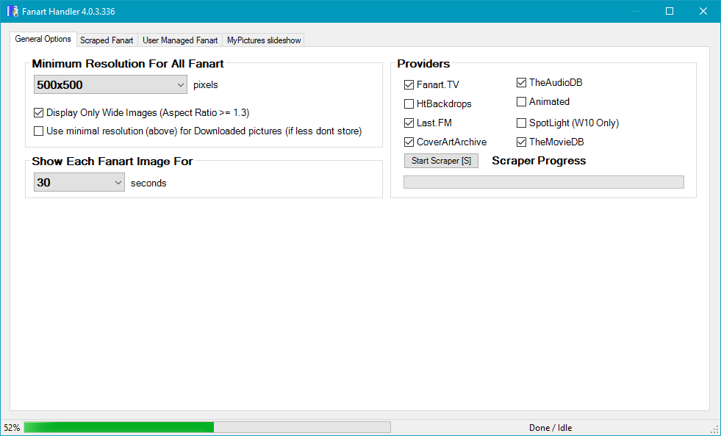
This action will ensure that the Fanart database is created (if it isn’t already there). Make sure you press Ok at the bottom of the Configuration application (closing the Configuration program) to ensure that the fanart set-up is saved.
You don’t really need to do anything else because the fanart database will be populated automatically when the MP1 GUI starts up and you will start to see background images for you movies and music.
NOTE: the fanart system will always clear down redundant data when the GUI is started.

Finally
You are now ready to use the MP1 system.

Subsequent Installations
When you install subsequent upgrades you shouldn’t need to delete existing databases unless explicitly told to do so. If you do delete the databases you will need to repeat stage 2.2.3.

